EACC Meeting 25 September 2025

1. Local Place Plans: Neighbourhood Opportunities and Challenges.
Ross Irvine; CEC Development Planning Team

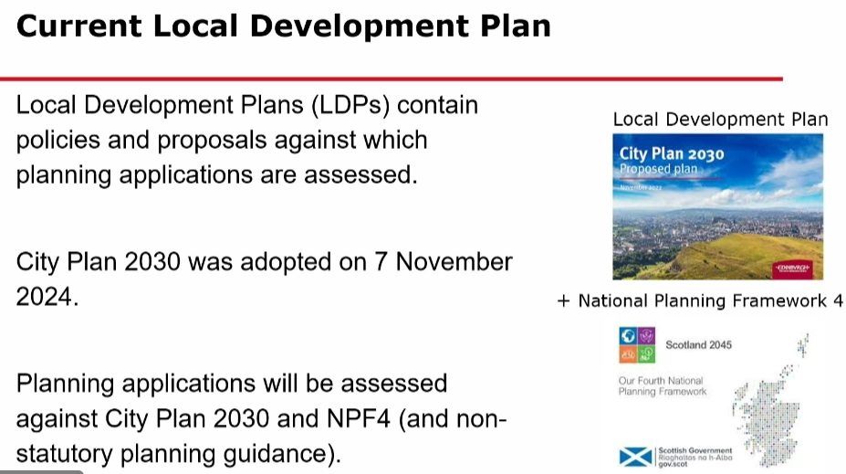

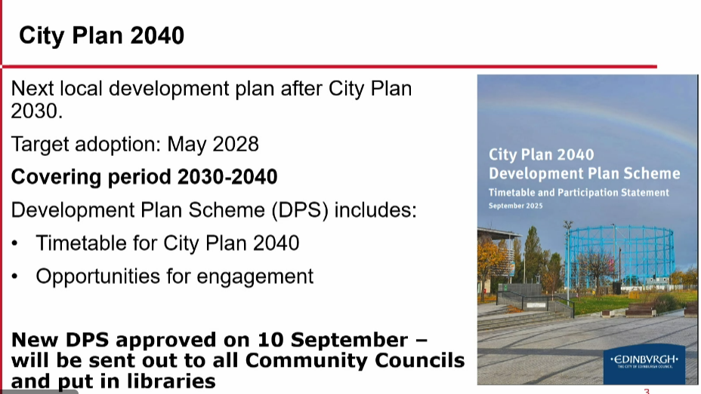

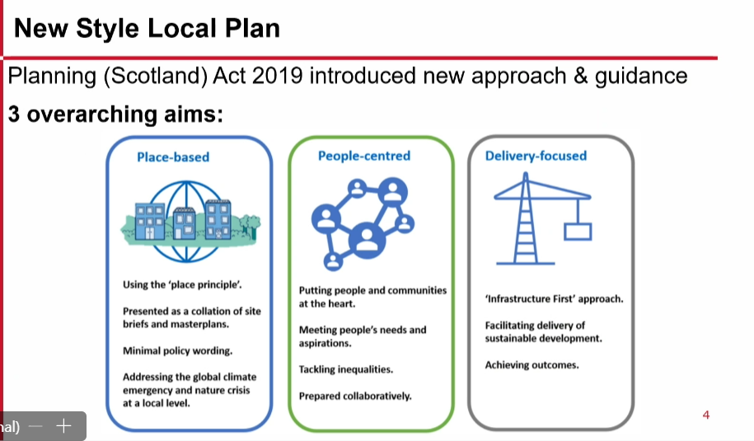

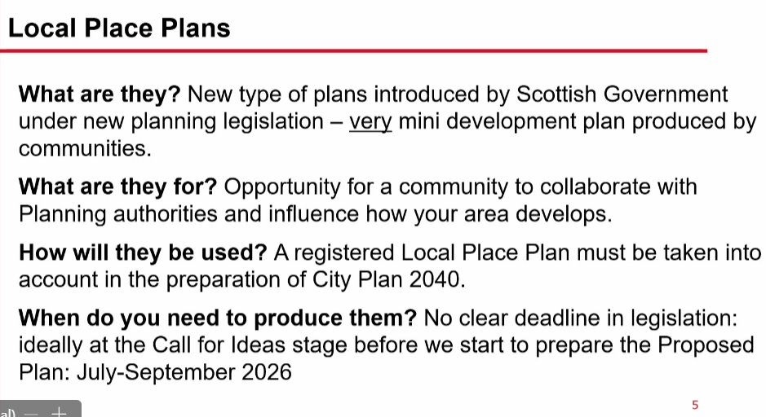

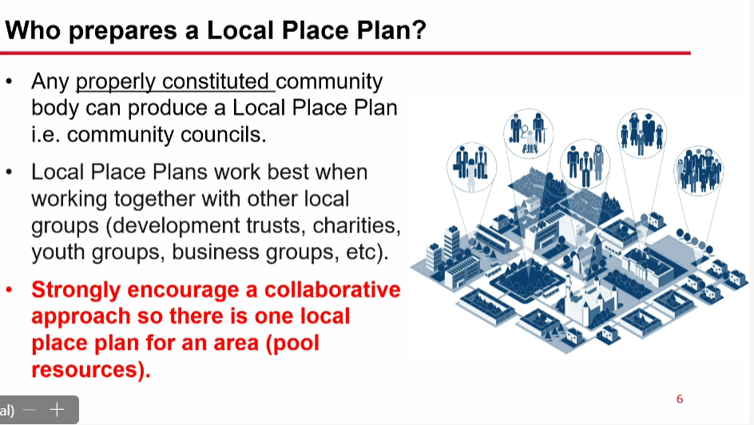

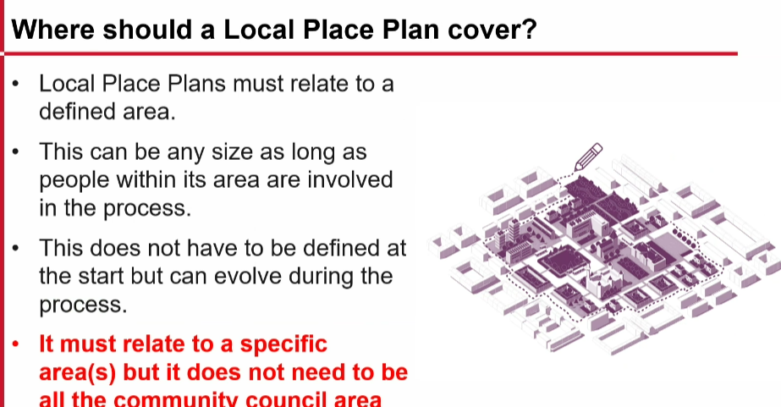

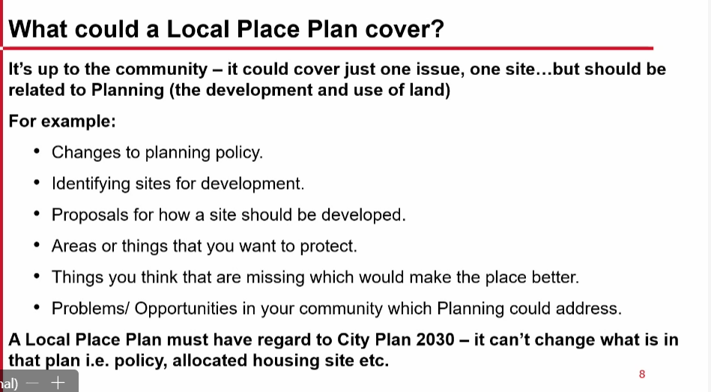

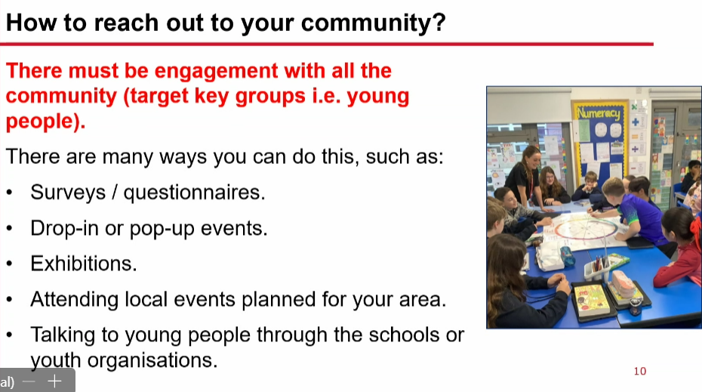

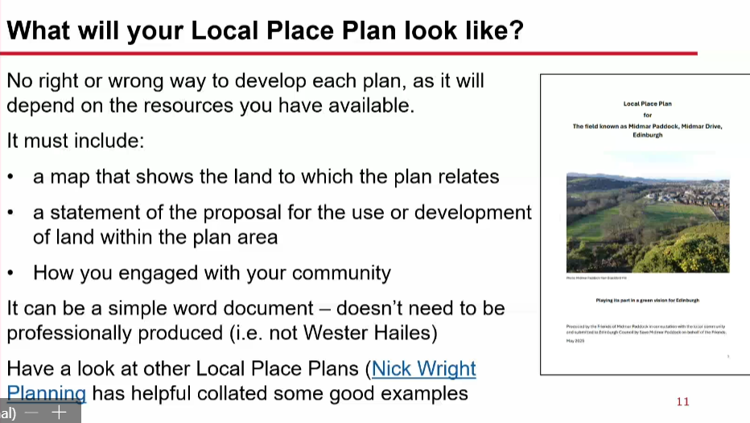

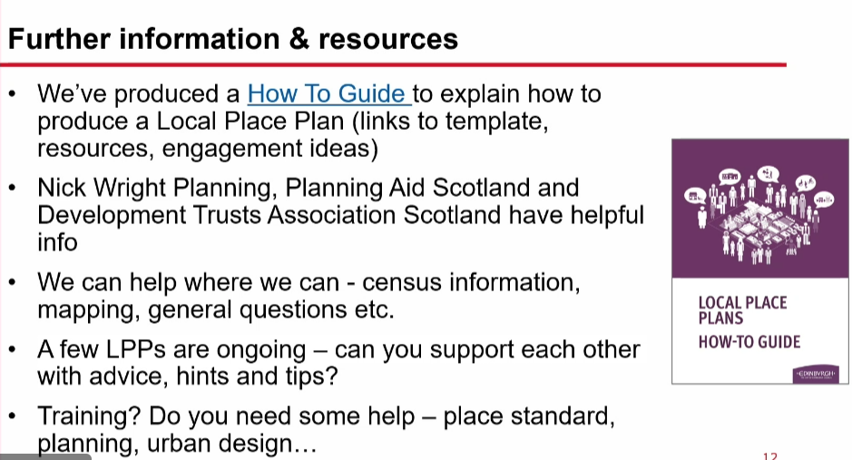

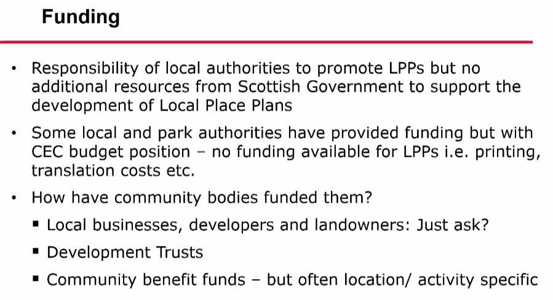

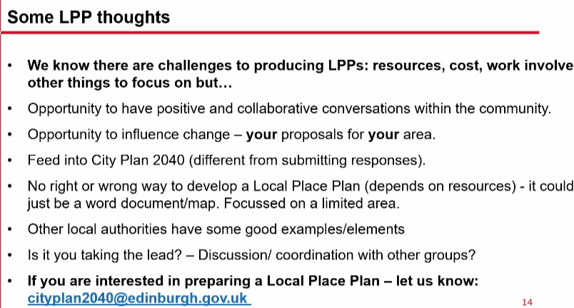

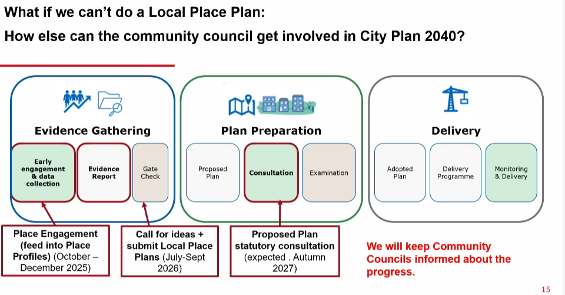

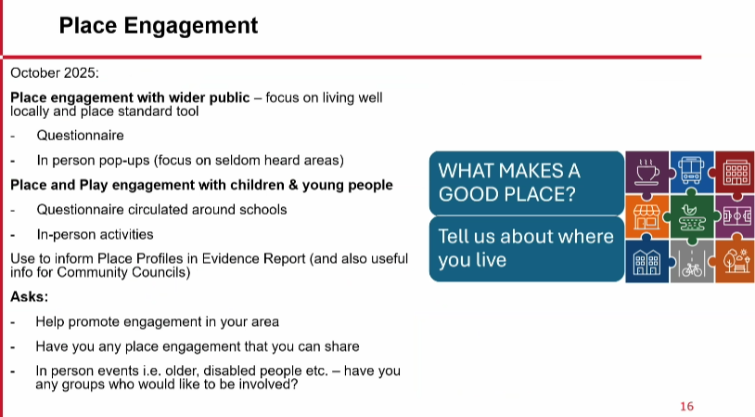

Transcript

26/09/25, from Ross Irvince
In addition, I wanted to follow up on a question asked which I did not have an immediate answer to, regarding how we will be assessing Local Place Plans and their proposals for Local Development Plan, particularly if there are proposed changes/conflicts with the City Plan.
There are no ‘rules’ set out by the Scottish Government as to how this is worked out. Based upon a review, other Councils have not published a step-by-step guide as to how they will carry/have carried this out.
I have been advised that the Local Place Plans will be followed by a ‘Call for Ideas’ stage around September 2026, in line with our Development Plan Scheme. (note that this DPS states July 2026 as the deadline, but following conversation with the team they can still be considered up to September 2026 alongside the Call for Ideas)
The preparation of the proposed plan will follow and must be backed up by studies to support the plan including site appraisal, transport and education appraisals, strategic environmental assessment, integrated impact assessment and biodiversity impact. Therefore, any Local Place Plan proposals, as well as ideas during the Call for Ideas, will need to be assessed against the same requirements as well as support shown through the Local Place Plan process.
Regardless, all Local Place Plans when registered, are considered a Material Consideration in the assessment of any application for planning permission in this area, but if there is conflict or disagreement with the City Plan/National Planning Framework then those plans would have stronger weight where the proposals have not been brought into the City Plan itself.

