EACC Meeting 29 January 2026: Slides and Summary Report
Part 1
1
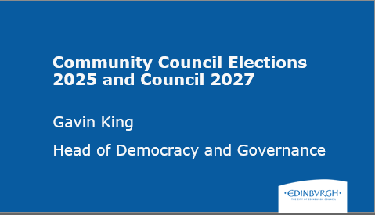

2
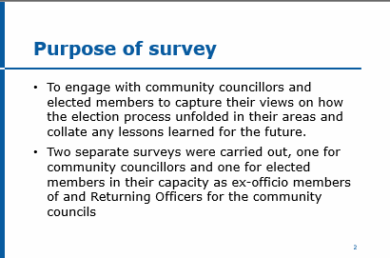

3
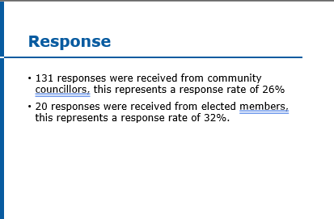

4
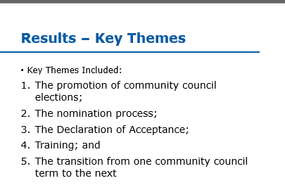

5
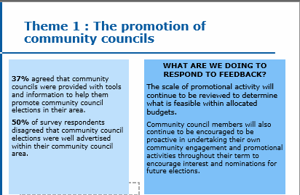

6
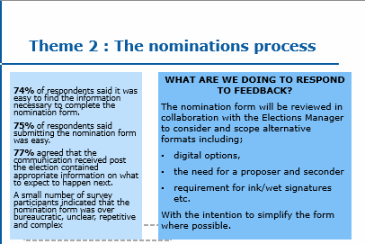

7
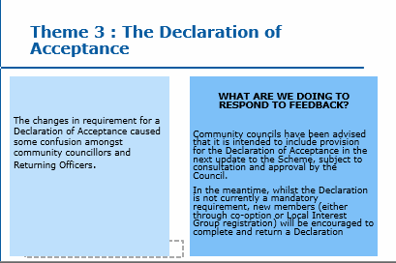

8
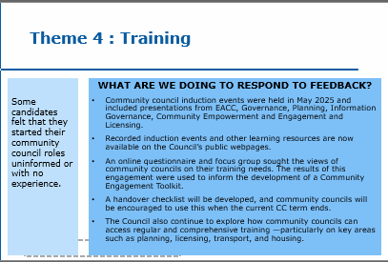

9
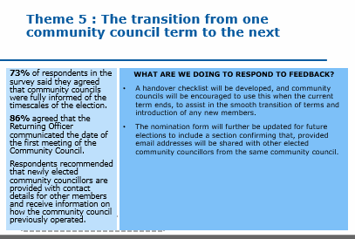

10
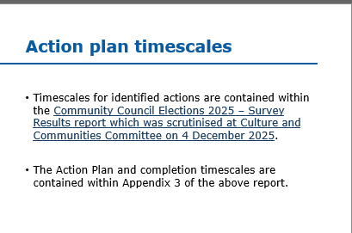

11
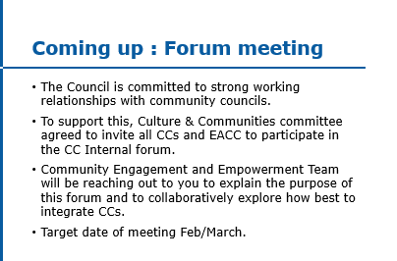

12
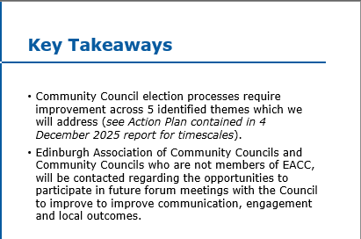

13
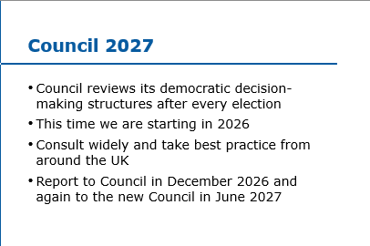

14

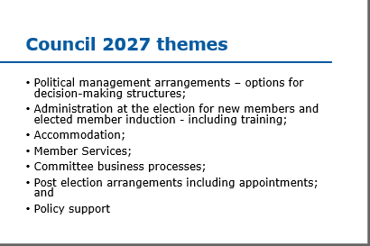

15
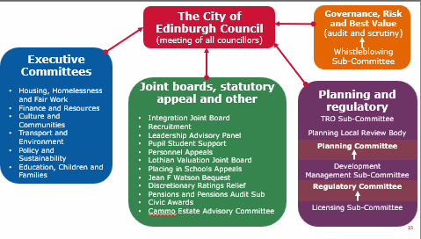

16
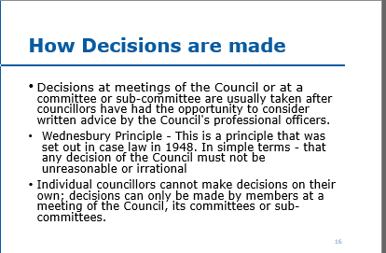

17
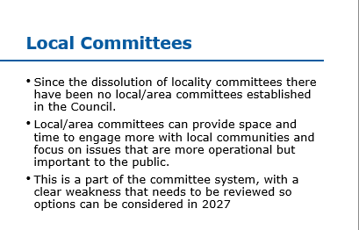

18
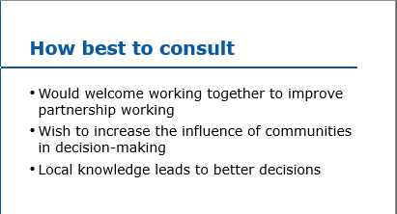

19
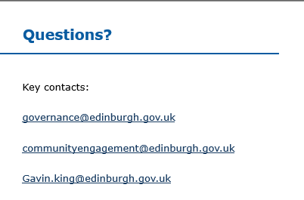

Summary of EACC Meeting – 29 January 2026

1. Overview
The meeting featured a detailed presentation by Gavin King, Head of Democracy and Governance at the City of Edinburgh Council, focusing on:
- Findings from the 2025 Community Council Elections Survey
- Planned reforms for Council 2027
- Strengthening partnership working between the City Council and Community Councils (CCs)
Following the presentation, an extended question-and-answer session involved multiple community councillors raising concerns about barriers to participation, communication challenges, democratic legitimacy, and future governance direction.

2. Summary of Gavin King's Presentation

2.1 Survey on 2025 Community Council Elections
Two surveys were issued:
- To Community Councillors — 26% response rate (131 replies)
- To City Councillors acting as returning officers — 32% (20 replies)
Gavin emphasised that the responses, while not comprehensive, offered clear insight into areas needing improvement.

Five Key Themes Identified

1. Promotion of Community Council Elections
- Only 37% agreed councils received adequate promotional support.
- 50% felt elections were poorly advertised locally.
- Gavin acknowledged promotional activity is a longstanding weakness and will require greater budget allocation and more targeted communications.

2. Nomination Process
- Around 75%+ found forms easy to access, complete, and submit.
- However, Gavin emphasised that even 25% finding the process difficult represents a significant barrier to participation.
- Plans include simplifying forms, offering alternative formats, and improving clarity.

3. Declaration of Acceptance
- Widespread confusion existed.
- Gavin accepted the form and process were unclear and require redesign before the next scheme review.

4. Training and Induction
- Many new CC members felt uninformed and unsupported.
- Council provided induction sessions and online resources, but Gavin admitted the process likely overloaded new councillors early on.
- Proposed solution: staggered, continuous training throughout the CC term.

5. Transition Between CC Terms
- 73% felt informed of election timelines; 86% knew their first meeting date.
- Issues arose around handover, continuity, and data sharing.
- Proposed improvements:
  - A formal handover checklist
  - Clarification of rules allowing email addresses to be shared among new CC members
  - Better guidance for first meetings
Gavin stressed that improving these five areas is essential for strengthening democratic engagement.

2.2 Strengthening Engagement Through Forums
The Council’s Culture & Communities Committee has agreed to invite all CCs and EACC into a new internal forum aimed at:
- Improving communication
- Establishing better working relationships
- Ensuring CCs have greater influence in Council decision-making
Target launch: February–March 2026.

2.3 Council 2027 Reforms
The Council's governance model is reviewed after each election. Gavin outlined major reforms being explored for 2027, including:

Aims
- Reduce the extremely high burden of committee reports (approx. 795 annually — more than any UK council).
- Improve decision-making efficiency
- Strengthen scrutiny and stakeholder engagement
- Modernise committee structures
- Adapt induction, training, and operational systems for new councillors

Challenges
- Edinburgh handles far more strategic and planning decisions than other cities.
- Committee workload is “breaking the back of the Council”.
- Legal restrictions (e.g., 1973 Act) limit delegation and prevent councillors acting individually.
- Expected addition of a sixth political group in 2027 will complicate majority formation.

Consultation Plans (2026–2027)
- Wide engagement across Scotland, England, Wales
- Consultation with CCs and local groups
- Report to current Council in Dec 2026
- Reconsidered by new Council in June 2027

2.4 Proposal for Local Area Committees
Gavin outlined early thinking on re-establishing or reimagining local area committees, stating:
- Current absence is a “clear weakness”.
- Local committees could improve local decision-making and reduce central committee overload.
- Past locality committees were “too large” and poorly devolved.
- New approach would prioritise:
  - Local knowledge
  - Faster decisions
  - Better engagement
  - Operational focus
- Still early in development — CC input is essential.

3. Summary of Q&A: Key Concerns and Contributions

3.1 Democratic Accountability & Role of Elected Councillors
Andrew Anderson expressed concern that officials may be driving reforms rather than elected members.
Gavin responded that:
- Officers provide advice, but councillors always decide.
- Multiple political groups ensure nothing is “nodded through”.
- The Wednesbury Principle requires decisions to be based on professional advice.
Some disagreement arose over the term “lay people”, but discussion moved on.

3.2 Barriers to Participation & Accessibility
Raised by: Dr Astri Kvassnes, Ian Doig, Tommy McLean

Key issues:
- Paper-only nomination forms disadvantage younger/less affluent candidates.
- Suggestion: Forms available in libraries.
- CCs struggle to recruit because timeframes are too short.
- Difficulty obtaining new members’ contact details delays forming functional committees.
- Transition between old and new CCs was effectively a “hard reset”.
Gavin agreed these were valid criticisms and committed to review.

3.3 Culture and Understanding Within the Council
Several contributors (Ian Doig, others) felt many officers:
- Do not understand CC roles
- View CCs as inconvenient
- Fail to meaningfully respond or provide timely information
Gavin acknowledged this cultural issue and said internal change is needed.

3.4 CC Influence, Impact, and Frustration
Repeated theme: CCs feel ignored.
Examples:
- Planning and traffic decisions
- Controlled Parking Zone (CPZ) boundary decisions
- Low response or engagement from council officers
- Need for demonstrated influence, not token consultation
Gavin agreed influence must be strengthened for the partnership to work.

3.5 Suggestions for Reform
Key suggestions from CC members:

1. Reinforce CCs instead of creating new local committees
(From David Houston)
- Redirect officer support to existing CCs
- Avoid adding bureaucratic layers

2. Conduct post-induction follow-up surveys
(From Richard Price)
To understand why new CC members leave prematurely.

3. Use specific case studies
e.g., CPZ decisions, Corstorphine engagement survey
To illustrate where processes failed and how they could be improved.
Gavin welcomed all suggestions.

4. Final Messages from Gavin King
- All feedback is valued and useful.
- Council is committed to improving processes, training, and relationships.
- He recognises the need for cultural change within the Council.
- Further written feedback and ongoing dialogue are encouraged.

Slide 16
Added comment from Andrew Anderson (Trinity CC)
Follow-up: this is the meaning of the Wednesbury Principles: "A standard of unreasonableness used in assessing an application for judicial review of a public authority's decision. A reasoning or decision is Wednesbury unreasonable (or irrational) if it is so unreasonable that no reasonable person acting reasonably could have made it (Associated Provincial Picture Houses Ltd v Wednesbury Corporation (1948) 1 KB 223). The test is a different (and stricter) test than merely showing that the decision was unreasonable." This decision has been argued about, and has led to differing interpretations, over the last 78 years.
Part 2
Corstorphine Clermiston Community Council – The Early Months
Donald Rutherford, Chair

The discussion focused on the experiences and challenges faced by newly formed or recently renewed Community Councils across Edinburgh. Several representatives shared practical barriers, lessons learned, and requests for improved support.

1. Challenges Setting Up New Community Councils
Donald Rutherford (Clermiston):
- Most members were entirely new to community council work, making the process daunting.
- Administrative hurdles:
  - Difficulty setting up a bank account, which delayed booking venues.
  - Public liability insurance was confusing; more guidance from Governance would’ve helped.
  - Setting up websites and email systems from scratch required substantial effort.
- Training gaps:
  - New planning officers felt overwhelmed by planning documentation without structured guidance.
- Scale of responsibility:
  - Large population (~21,000) made community engagement difficult with limited volunteers.
- Suggested mentorship from more experienced community councils.
- Requested online sessions tailored for new councils to allow faster Q&A.

2. Governance, Minutes, and Expectations
Dr Astri JS Kvassnes:
- Clarified expectations around minutes: councils won’t lose their voice if late; consequences are mild.
- Stressed the need for clear explanations of what tasks must be done, and how urgent they truly are.

3. Experience from Colinton CC
David Bewsey:
- Minutes don’t need to be word-for-word; they should capture:
  - key subjects discussed
  - decisions made
  - who made them
- Zoom recordings can help minute-taking.
- Biggest issue: community engagement—attendance dominated by a few individuals with personal issues.
- Warned against councils becoming focused on individual complaints.
- Praised the published guidelines, saying they are clearer than the Scheme.
- Offered IT support to other councils.

4. Experience from Cramond, Barton & Cammo
John Loudon:
- Council is mostly new members; many have young families and little time.
- No secretary—using AI tools successfully for minutes.
- Initial communication between new members was chaotic due to lack of email addresses.
- Faces several major local issues (e.g., Barton Junction, White House Road, airspeed changes), placing heavy demands on a small core of active members.
- Difficulty recruiting a new chair.

KR

