EACC Meeting 26 February 2026
Planning Democracy: Manifesto for Change 2025: Clare Symonds (Chief Officer)
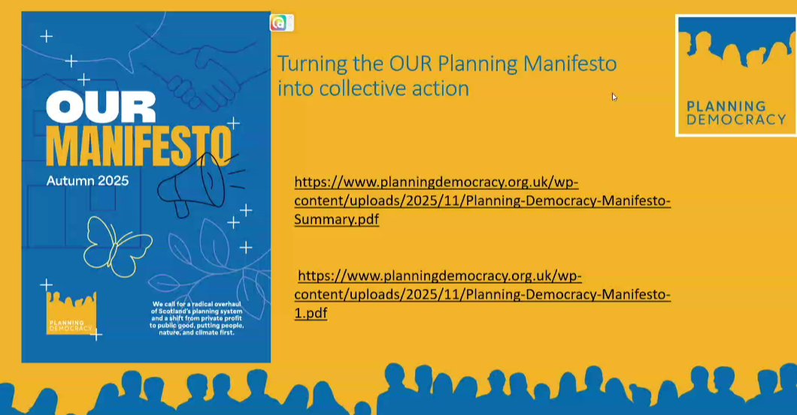
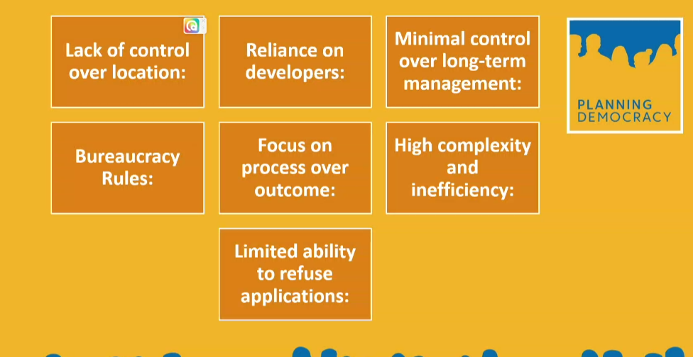

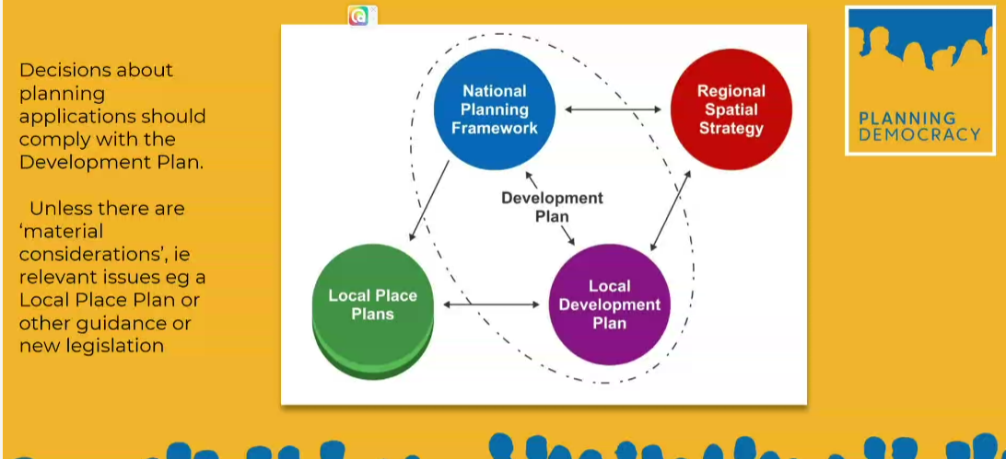

Outline of Manifesto
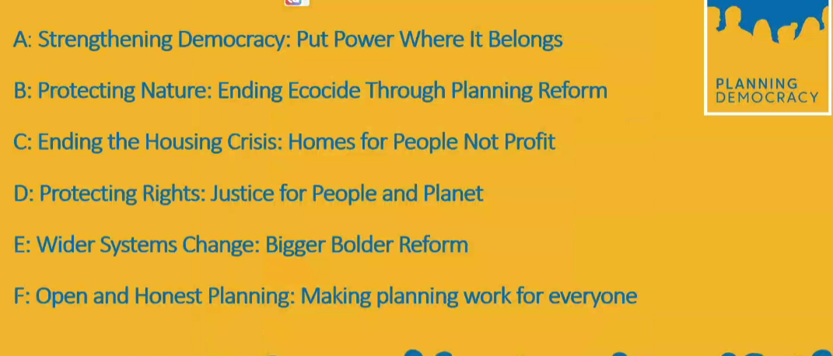
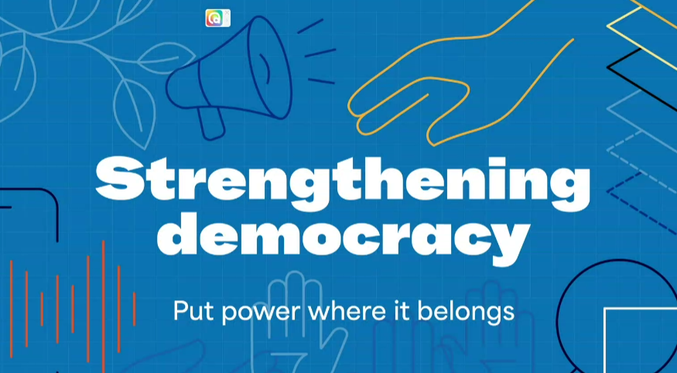

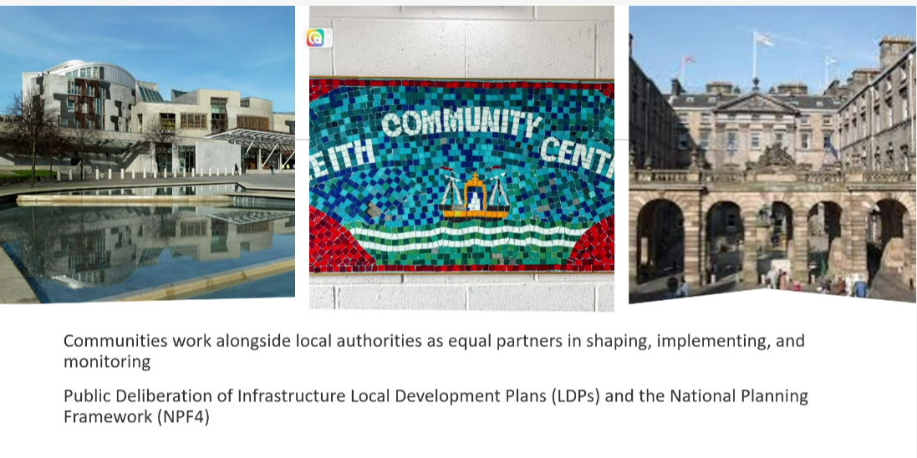
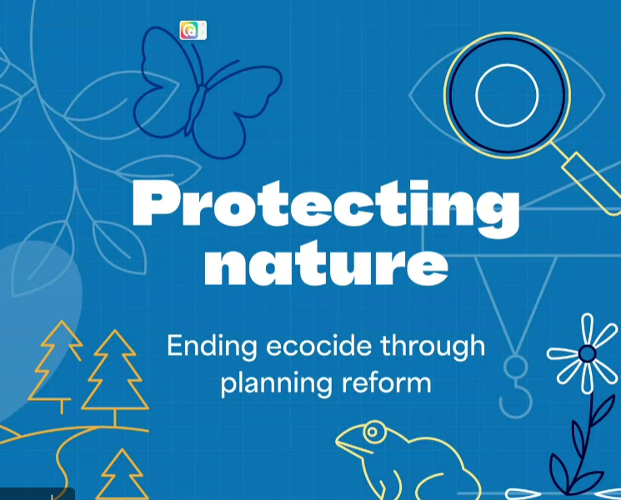
Reference recent National Security Document on Ecological Collapse
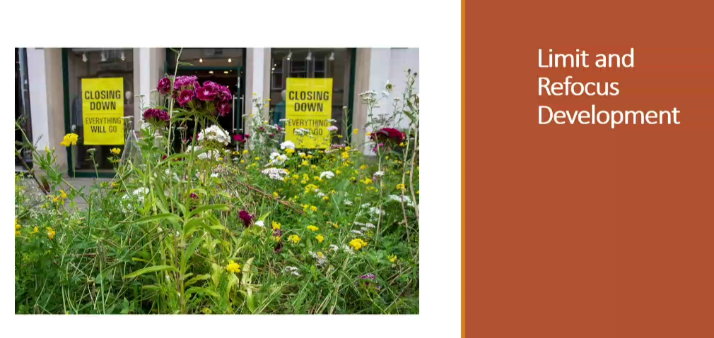
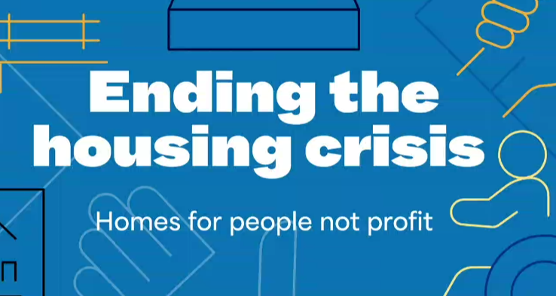


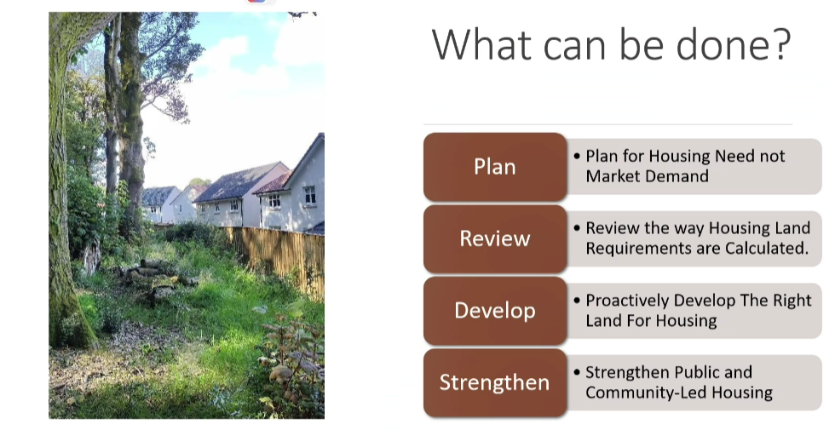


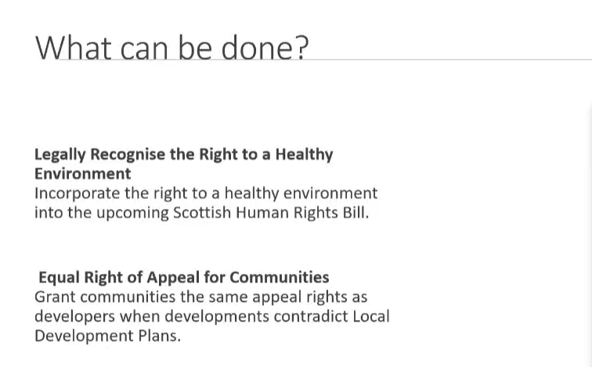







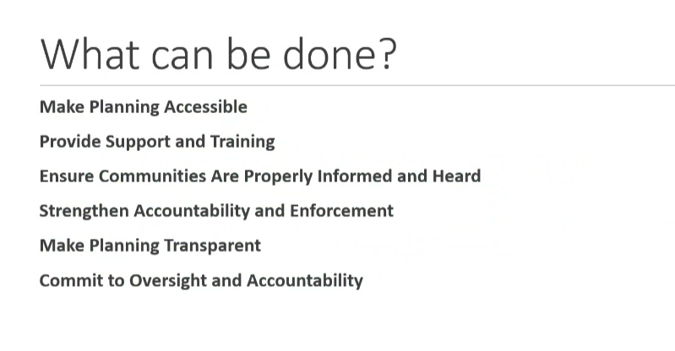



Refer to Scottish Land Commission on Public Land Assembly
Summary

EACC Meeting: 26 February 2026

Planning Democracy: Manifesto for Change 2025

1. Introduction and Context
A presentation by Clare Symonds from Planning Democracy, an organisation advocating for a more democratic, community-led planning system in Scotland. Clare outlined the motivations behind their expanded campaign work and the development of a new, comprehensive planning reform manifesto aimed at influencing political agendas ahead of the 2026 Scottish Parliament elections.

Planning Democracy works with universities, planning academics, community organisations, and networks such as the Scottish Community Alliance and Scottish Environment Link. Their overriding aim is ensuring communities and the environment have a stronger voice in planning decisions.

2. Diagnosis of Problems in Scotland’s Planning System

2.1 A Reactive, Developer-Led System
Clare argued that although Scotland technically has a "plan-led" system (NPF4 plus Local Development Plans), in practice:
- Planning authorities lack the power to direct development to appropriate locations (e.g., brownfield sites).
- Councils wait for developers to bring forward proposals, making public outcomes dependent on private profitability.
- The system functions as a regulatory filter rather than true planning.
- Development decisions often override local plans, especially when developers exert pressure through appeals.

2.2 Structural Imbalance of Power
Communities face clear disadvantages:
- Developers have greater access, resources, and appeal rights.
- Public engagement is typically superficial and framed around informing rather than empowering communities.
- Complex processes, digital systems and jargon create barriers to participation.
- Community concerns are often dismissed as NIMBYism.
- Local authorities are under-resourced and overwhelmed.

2.3 Weak Implementation of Progressive National Policies
Although NPF4 was internationally recognised for strong climate, biodiversity and community wealth-building policies, Clare stressed that practice on the ground has barely changed. The planning system’s discretionary nature and market incentives continue to dominate outcomes.

3. Overview of Planning Democracy’s Manifesto
The manifesto argues the central issue is democratic deficit, and that meaningful reform requires communities to be positioned as:
- First parties in planning decisions,
- Decision-makers and land stewards, not merely consultees,
- With developers treated as third parties, akin to service providers.
Clare outlined key chapters of the manifesto:

3.1 Restoring Democratic Control
- Give communities a formal role as equal partners with local authorities in shaping, implementing and monitoring development plans.
- Strengthen legal weight of Local Place Plans.
- Reduce the discretionary nature of decision-making.
- Empower planning authorities to refuse proposals that contradict democratically agreed plans or exceed ecological capacity.
- Expand deliberative democracy tools (citizens’ assemblies, liaison panels).
- Support a shift toward more localised, municipal democratic structures.

3.2 Protecting Nature and Climate
Clare emphasised Scotland’s status as “one of the most nature-depleted countries in the world”. She referenced the UK National Security Assessment warning of potential ecological collapse within four years.

Key proposals:
- Enforce ecological and climate limits within planning.
- Require carbon budget assessments for major developments, including data centres.
- Reduce land take and resource consumption by development.
- Strengthen biodiversity protection by closing implementation gaps in existing legislation.

3.3 Ending the Housing Crisis
Clare challenged the dominant narrative that the housing emergency is caused by lack of supply alone. Instead:
- Volume housebuilders profit from scarcity and have no incentive to resolve it.
- Scotland has 250,000 people on social housing waiting lists, but speculative development focuses on profitable areas rather than need.
Recommendations:
- Reform Housing Need and Demand Assessments and the Minimum All-Tenure Housing Land Requirement methodology.
- Reduce overly generous land allocations to volume developers.
- Prioritise public-led and community-led housing, including development corporations and land assembly.
- Regulate second homes, utilise vacant and derelict land, and bring empty homes back into use.
- Focus on affordability, not just unit numbers.

3.4 Protecting Community Rights
- Introduce equal rights of appeal for communities (currently they have none).
- This aligns with obligations under the Aarhus Convention, where Scotland is likely in breach.
- Clare argued that appeals could be limited to clear conditions (e.g., proposals contrary to the development plan) to avoid system overload.

3.5 Planning for Systems Change
- Promote public and community-led development models, inspired by historic New Town development corporations and European land assembly approaches.
- Use compulsory purchase and land value capture to stop profit leakage from local economies.
- Tackle extractive land economics and shift toward long-term stewardship.

3.6 Open and Accessible Planning
- Simplify documentation and digital systems.
- Improve notification, public access, and enforcement resources.
- Standardise planning committees with equal speaking rights for communities.
- Invest in support and training for community councils and local councillors.

4. Questions, Concerns and Discussion Points from Participants

4.1 Economic Feasibility and Transition Risks
Several participants (including Ken Robertson) questioned:
- Whether proposals imply large-scale wealth redistribution.
- The economic risks of rapidly shifting to a community-led system.
- Whether such a transformation could cause short-term economic disruption.
Clare responded that:
- Existing systems are extractive, removing wealth from communities.
- European land assembly models demonstrate viability.
- Public-led development historically delivered better long-term outcomes.

4.2 Capacity of Community Councils
Many contributors (e.g., Norman Rees) highlighted:
- Overwhelm, burnout and lack of support for community councillors.
- Severe resourcing issues within City of Edinburgh Council, leading to slow or no responses.
- Constant “firefighting” against inappropriate developments.
Clare acknowledged this and emphasised the manifesto is designed to fix the system that forces communities into endless reactive work.

4.3 Housing Delivery, Skills Shortages and Infrastructure
Points raised included:
- Acute shortages of construction workers and technical trades.
- Lack of manufacturing capacity for low-carbon building systems.
- Concerns about building "homes" versus building "communities".
Clare agreed these broader systemic challenges need consideration but reiterated that Scotland should prioritise social housing, better use of existing stock, and more realistic housing needs assessments over simply expanding greenfield development.

4.4 Student Housing and Short-Term Lets
Participants from dense urban areas (e.g., Tollcross, Merchiston) raised concerns:
- Uncontrolled proliferation of student housing distorts communities.
- Council feels powerless due to Scottish Government appeal tendencies.
- Short-term lets overwhelm both planning departments and housing availability.
- Current penalties are too weak to deter non-compliance.
Clare agreed these effects align with systemic problems the manifesto aims to address, and welcomed further examples for inclusion.

4.5 Right of Appeal – Preventing Abuse or Gridlock
Participants queried whether equal appeal rights could:
- Paralyse planning,
- Be exploited by organised interest groups,
- Overwhelm local authorities.
Clare countered that:
- Developers already cause the majority of appeals.
- Appeals could be restricted to cases of significant inconsistency with development plans.
- Justice and fairness should not be sacrificed to avoid administrative inconvenience.

5. Closing Remarks
The meeting concluded with:
- A broad recognition of the challenges facing the planning system.
- Acknowledgement that while proposed reforms are ambitious, incremental adjustments are insufficient.
- An invitation from Clare for community councils to endorse the manifesto, promote it to elected representatives, and contribute further evidence or suggestions.

There was appreciation for Clare’s presentation and her organisation’s work. Several attendees expressed support for the manifesto’s direction, even where minor differences of emphasis remained.

Other EACC Business
1) From Community Empowerment & Engagement Team 8 Jan 2026
Community Grants Fund Volunteer Celebration Event Tuesday 24 March at City Chambers (18.00 to 19.30). RSVP by 9 March

2) Norman Rees, Corstorphine East West Craigs CC
Parallel Lib Dem surveys on a bus gate proposal (two Elected Councillors, two neighbouring wards, EWC CC sits in both). Separate survey results and separate push on conclusions. EWC CC caught in the middle.
‘Best to sit still’.

3) Cameron Toll Redevelopment: early proposals.
Massive scale: Residential, PBSA, Hotel, Hospitality, Retail, Leisure, Tram / Train Hub. Complete re-ordering of the site. 7+ storey profile in prospect.
Developer Reps due to speak at 30 March Liberton & District CC meeting, at King’s Buildings.
Contact David Cavanagh at Liberton & District CC

END

